2009 set of Cyprus euro coins
APPLICATION FORM FOR PROFESSIONAL COIN DEALERS IN CYPRUS

To:  CENTRAL BANK OF CYPRUS  P.O.Box. 25529  CY-1395 Nicosia  E-mail: numismatic.orders@centralbank.gov.cy  Fax: 00357 22 379307 |  | 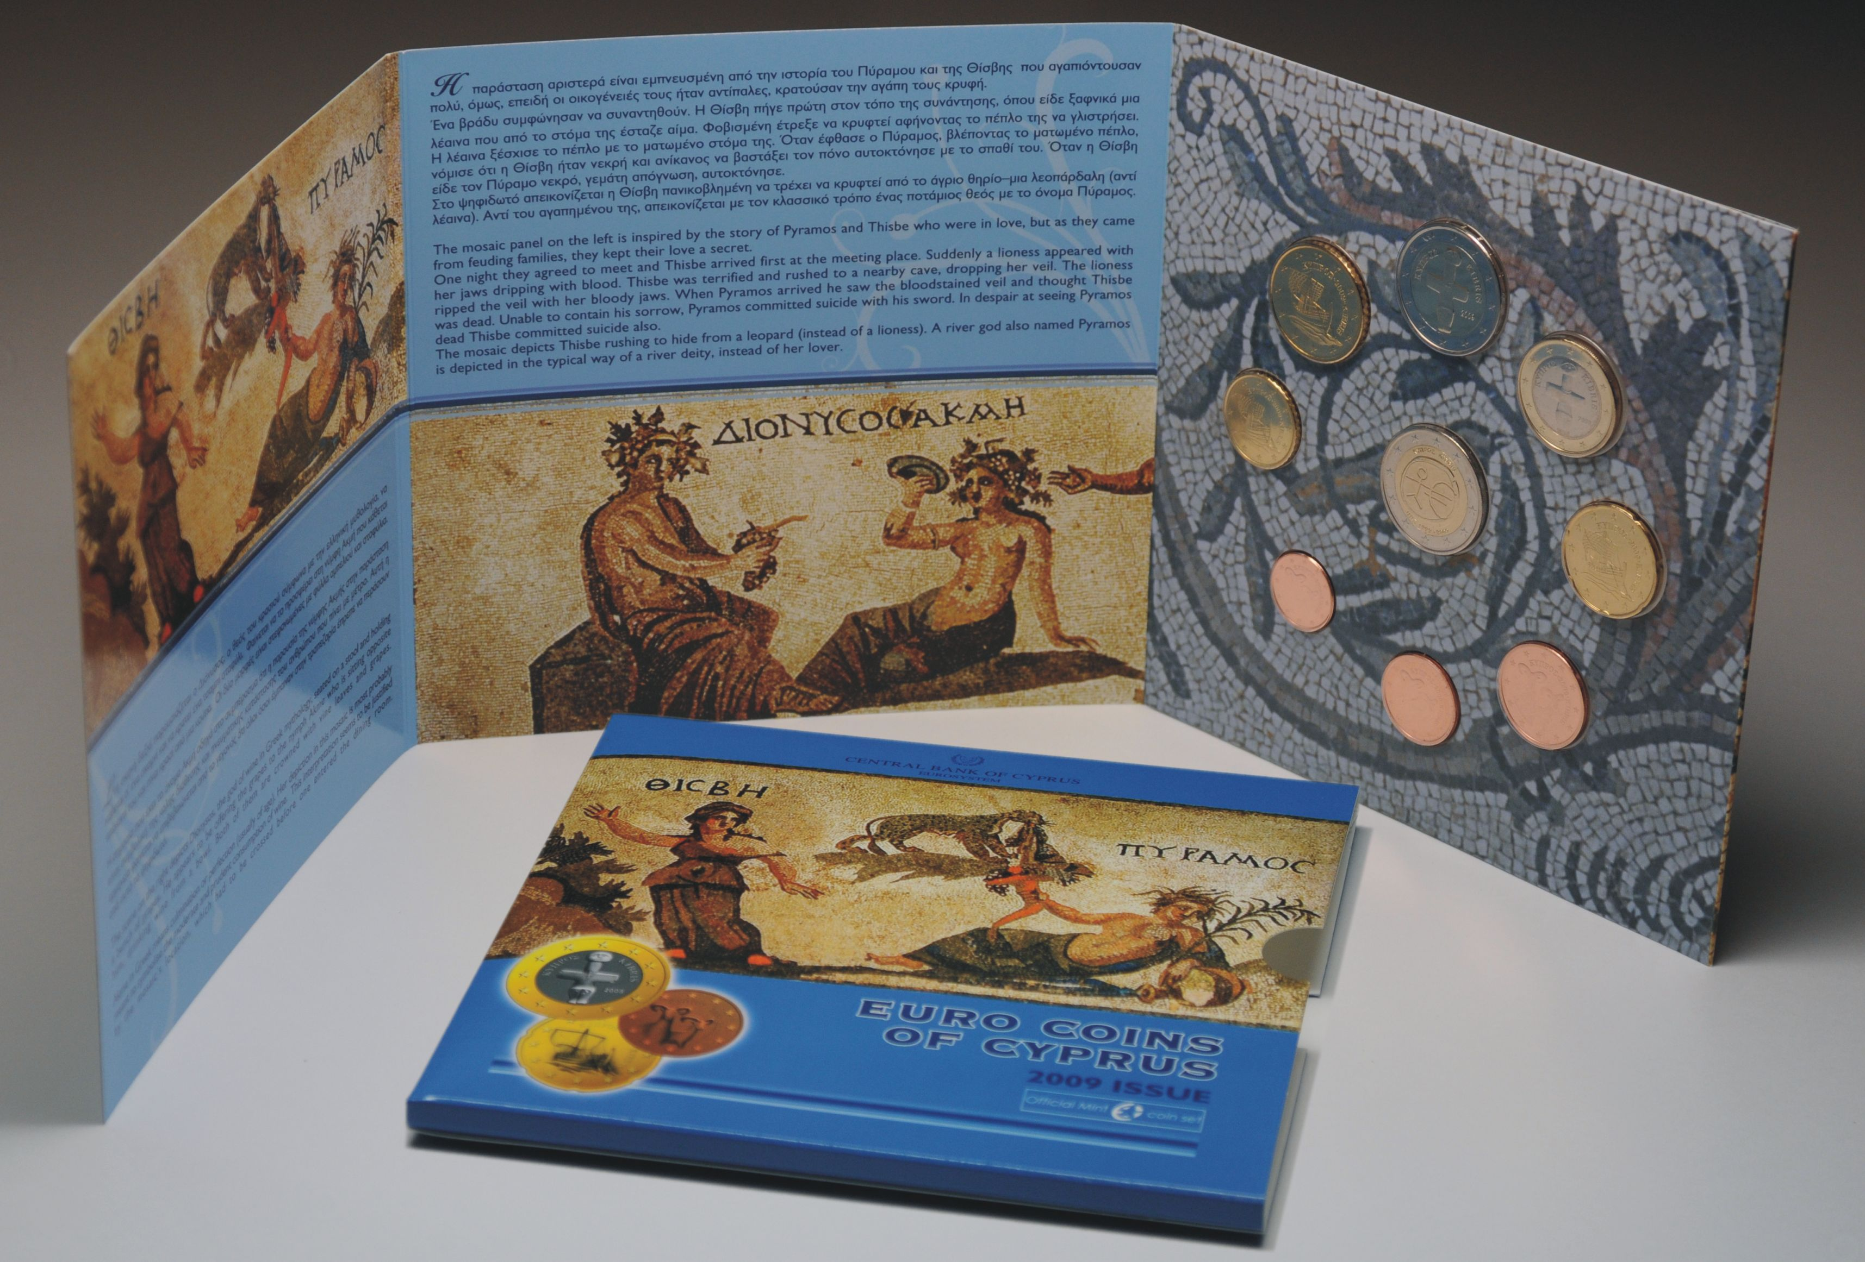
Applicant’s details
1. Name : ...................................................................................................................
2. Address : ....................................................................................................................
3. Postal Code : ....................................................................................................................
4. Tel. Number : ....................................................................................................................
5. Fax Number : ....................................................................................................................
6. E-mail : ....................................................................................................................

I apply to purchase the following
2009 set of Cyprus euro coins | Number of sets

...............................  Date | ……………………………..  Signature of applicant

